1. **How to Import SAS XPORT Files into R With The foreign package**

**Ans.**

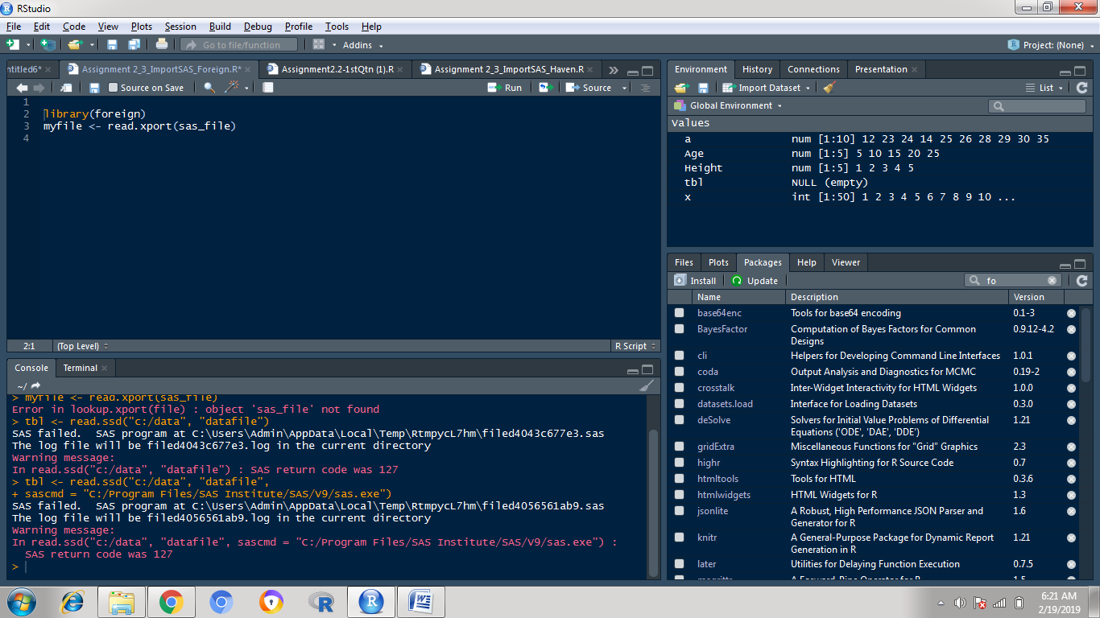

1. **How To Import SAS Files into R With The haven Package?**

**Ans**

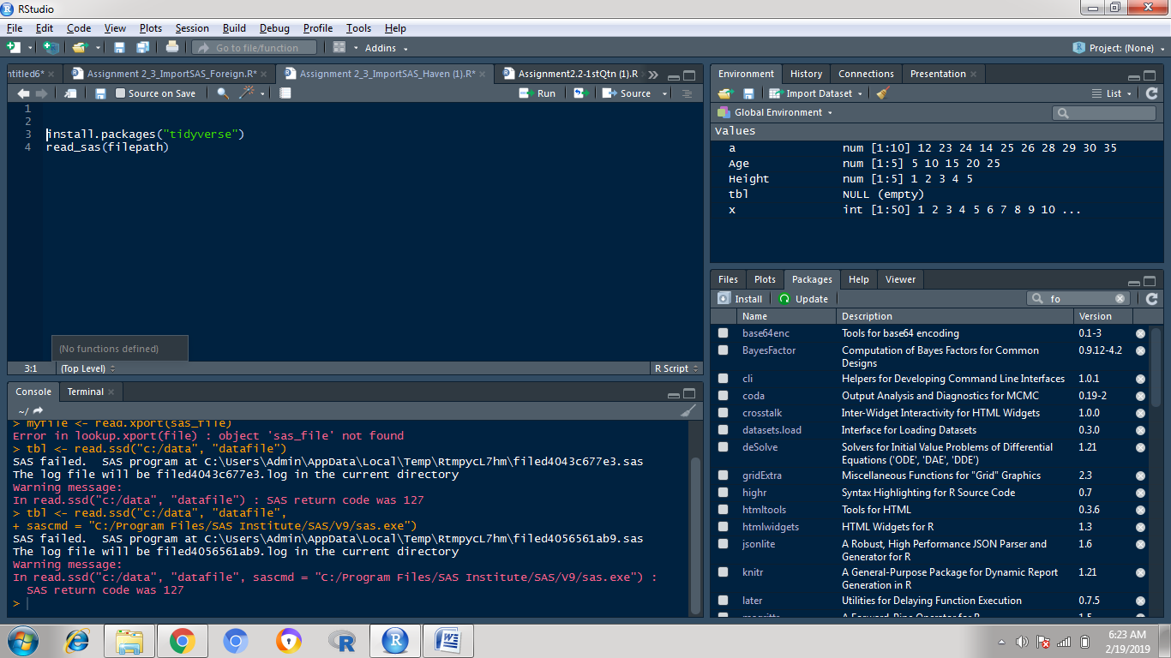

1. **How to read Weka Attribute-Relation File Format (ARFF) files in R?**

**Ans**

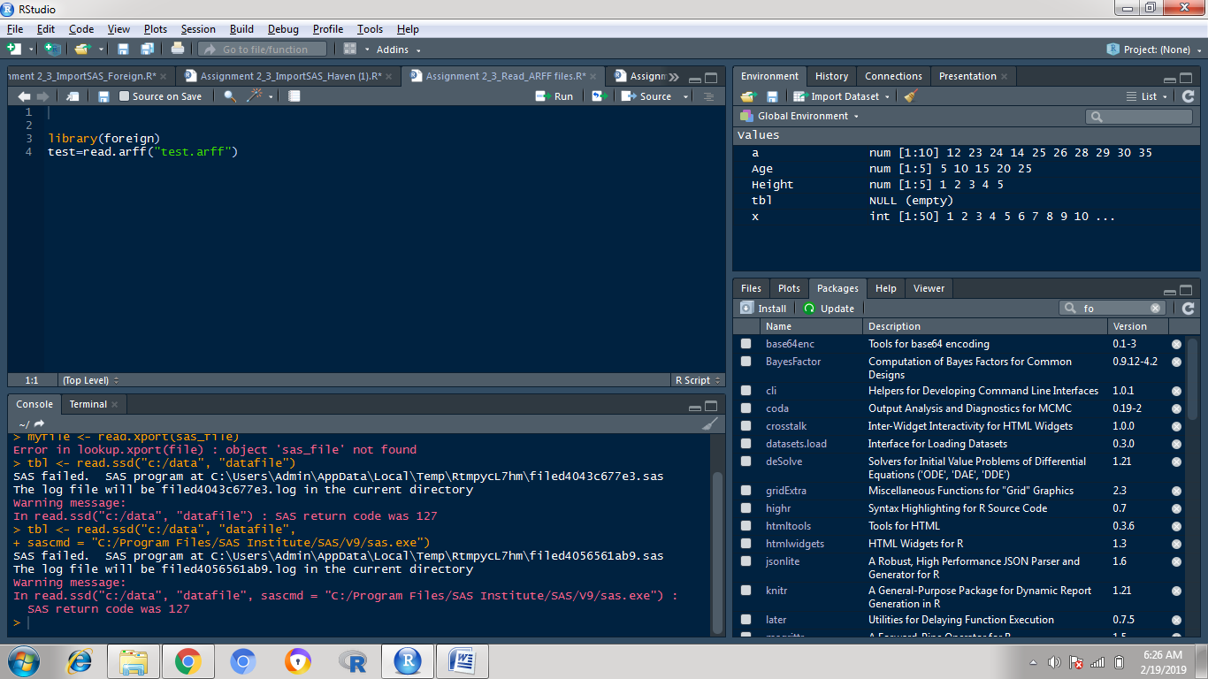

1. **How to read a heavy csv/tsv file using readr package?**

**Ans**

